

NAME- Amritanshu Kumar

ROLL NO- 1/21/FET/BCS/027

SECTION- 5CSA1

ntroduction to Github

Git Bash Commands?

Git Bash is packaged with additional commands that can be found in the /usr/bin directory of the Git Bash emulation. Git Bash can actually provide a fairly robust shell experience on Windows. Git Bash comes packaged with the following shell commands which are outside the scope of this document: Ssh, scp, cat, find.

In addition the previously discussed set of Bash commands, Git Bash includes the full set of Git core commands discussed through out this site. Learn more at the corresponding documentation pages for git clone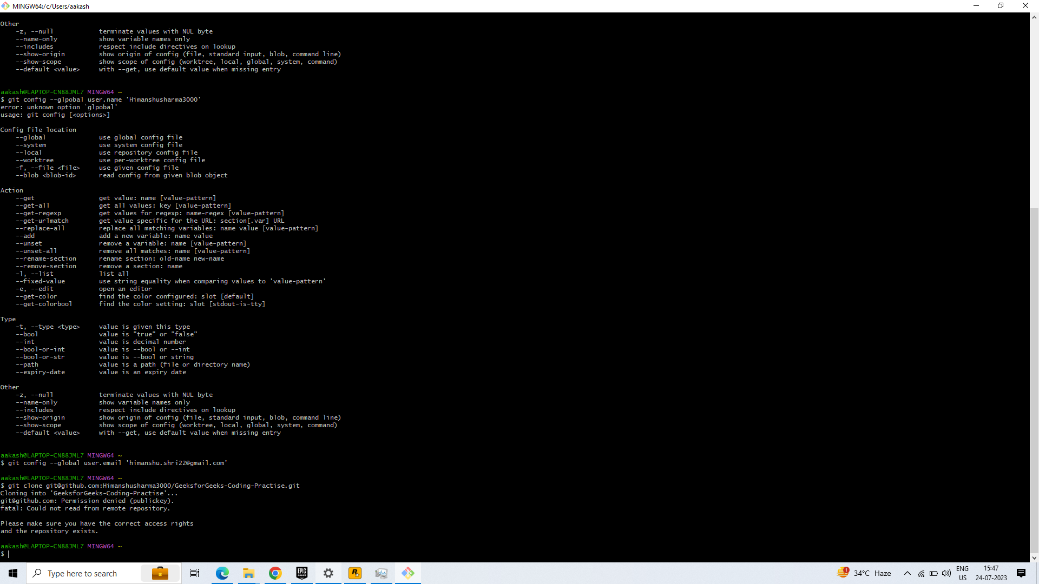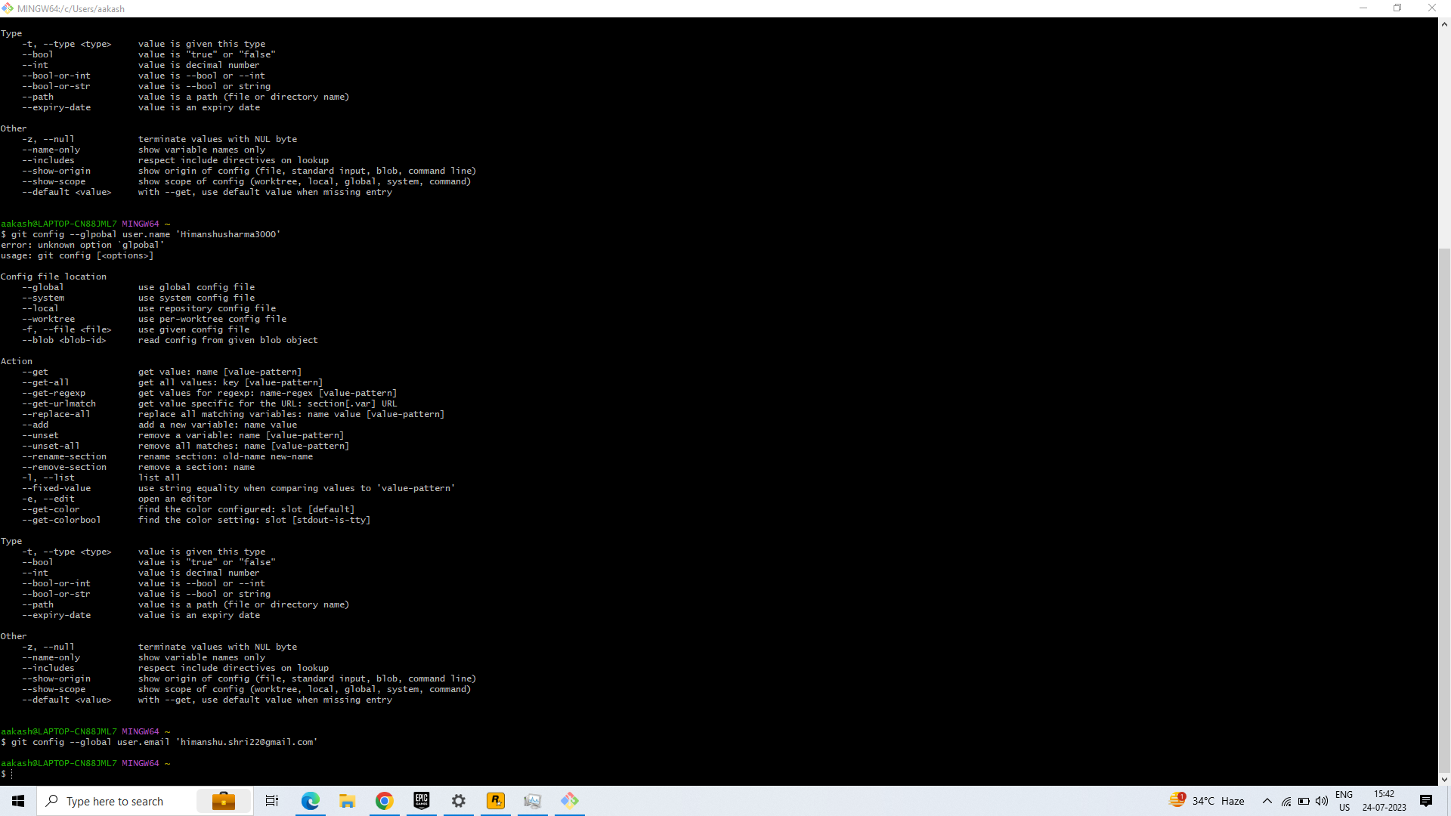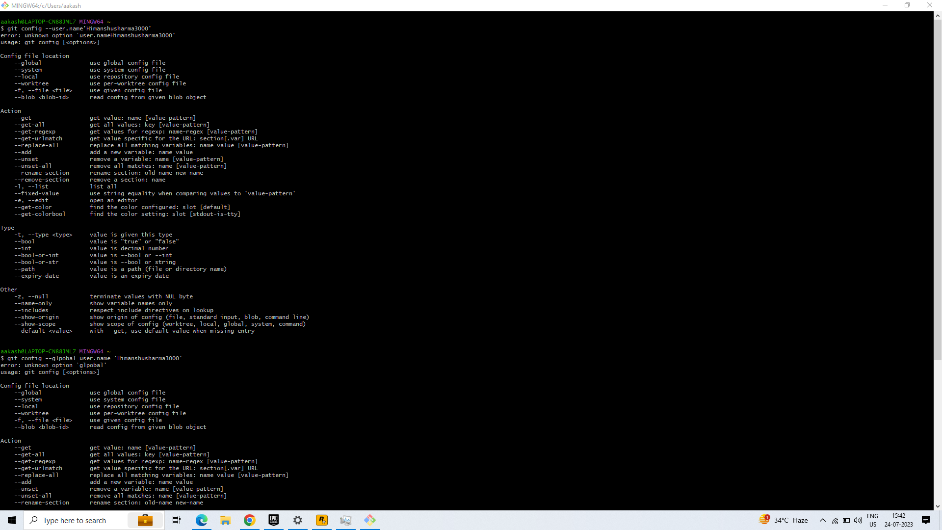

What is Visual Studio Code used for?

Visual Studio Code is a streamlined code editor with support for development operations like debugging, task running, and version control. It aims to provide just the tools a developer needs for a quick code-build-debug cycle and leaves more complex workflows to fuller featured IDEs, such as Visual Studio IDE.

Steps for Cloning Local account to vs account

